Empathy-Enhanced Chat Bot for Customer Support
Introduction
In the era of digital transformation, businesses increasingly rely on chatbots to handle customer support because of their speed, scalability, and round-the-clock availability. However, most chatbots focus purely on transactional efficiency, answering queries correctly and quickly, while lacking the emotional competence to perceive and respond to users’ feelings. This emotional gap can leave users feeling frustrated or unheard, even when their problems are technically resolved (Bilquise, Ibrahim, & Shaalan, 2022).
To address this, recent research has begun exploring emotion-aware or empathy-enhanced chatbots, which can detect emotional states in user input and respond in a more humanlike, supportive way. For example, a hybrid BERT + Bi-LSTM architecture has been used to detect emotional distress and support psychological first aid (Taiwo & Al-Bander, 2025). Meanwhile, empirical studies show that large language models like ChatGPT can generate responses perceived as empathic, outperforming humans in some controlled settings (Elyoseph et al., 2023).
Still, embedding empathy into conversational agents is nontrivial. In healthcare settings, research warns that “‘experiential empathy’ from chatbots may feel inauthentic” and that instrumental support (practical advice) may sometimes be more appropriate (Seitz, 2024). Moreover, studies on how users perceive empathy from AI suggest that users often rate chatbots as less empathetic than human interlocutors, even when the chatbot’s language mirrors human empathy (Liu et al., 2024). In mental health contexts, integrating BERT-based emotional distress detection with a GPT-powered chatbot has shown promise for providing psychological first aid, demonstrating both opportunities and challenges for emotion-aware support (Taiwo & Al-Bander, 2025).
In parallel, research on emotion-aware chatbots in collaborative environments reveals how agents with emotion capabilities can influence social dynamics, emotional tone, and collaboration efficiency (Benke, Gnewuch, & Maedche, 2022). Though in a different domain, this work underscores the potential and challenges of designing bots that monitor emotional cues and adjust behavior.
Bearing these insights in mind, the goal of our project is to design a chatbot that not only resolves customer issues but also senses and responds to users’ emotional states. Specifically, our system will:
- Detect emotional states (e.g. frustration, confusion, calm) in customer messages using textual (and possibly multimodal) cues.
- Generate empathetic responses tailored to that emotional state, offering apologies, reassurance, clarifications, or calm redirections.
- Strike a balance between emotional support and operational efficiency, avoiding overly verbose or patronizing replies.
- Evaluate both task-based metrics (resolution, response time) and affective metrics (user satisfaction, perceived empathy, trust).
By integrating emotional awareness into customer support, our chatbot aims to bridge the gap between mechanistic automation and human-level care, thereby enhancing user experience and brand perception.

Distilbert model for chat bot:
Dataset used for DistilBERT: (Pegah & Sahar)
To train and evaluate the chatbot, a customized dataset was created. In the first stage, approximately 200 sentences were collected across six emotional categories: frustrated, excited, sad, happy, neutral, and angry. The data was sourced from two main origins:
1) Kaggle datasets, especially the Empathetic Dialogues – Facebook AI, which provided valuable examples of empathy-driven conversations.
2) Online customer reviews and feedback, which added realism and diversity to the dataset.
The data was structured in a tabular format with four key columns:
- user_text – input sentences from users
- emotion – the emotional label of the text (six main categories)
- neutral_reply – a standard, neutral response
- empathetic_reply – a response designed to express empathy
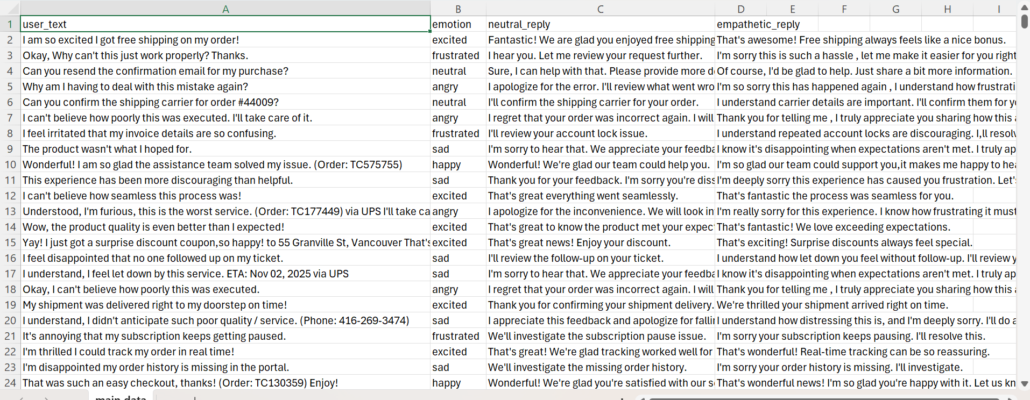
Dataset Expansion
The initial version contained about 30–35 sentences per emotion category, which aligns with recommended practices by Microsoft LUIS/CLU and Oracle ODA for development projects. To improve accuracy and generalization, the dataset was expanded to 638 sentences in the second version.
Oracle:
Train Your Model for Natural Language Understanding

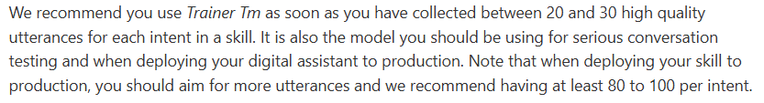
Microsoft:
Conversational language understanding best practices - Azure AI services | Microsoft Learn
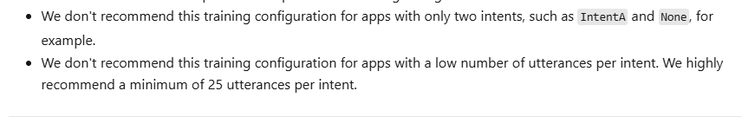
Alignment with Industry Standards
- Microsoft (LUIS/CLU): 30–50 examples per intent recommended → our dataset meets this range.
- Oracle ODA: 20–30 examples sufficient for development, 80–100 for production → our dataset is suitable for academic and prototype use.
Finally:
By combining Kaggle data and real-world online reviews, the dataset was gradually expanded to support chatbot training and testing. The final version, with 638 labeled sentences, is sufficient for academic and development purposes. However, for production-level deployment, additional data diversity and augmentation techniques (such as paraphrasing and synonym replacement) would be required.

Distilbert Model: in Google Colab, T4 GPU (Pegah & Sahar)
DistilBERT is a smaller, faster, and more efficient version of the BERT language model, created by Hugging Face using a technique called knowledge distillation, where a large model teaches a smaller one to mimic its behavior. It retains about 95–97% of BERT’s performance while being 40% smaller and 60% faster, making it ideal for real-world applications with limited resources. Like BERT, it is pretrained on massive text data and can be fine-tuned for a variety of NLP tasks such as text classification, sentiment analysis, question answering, and named entity recognition.
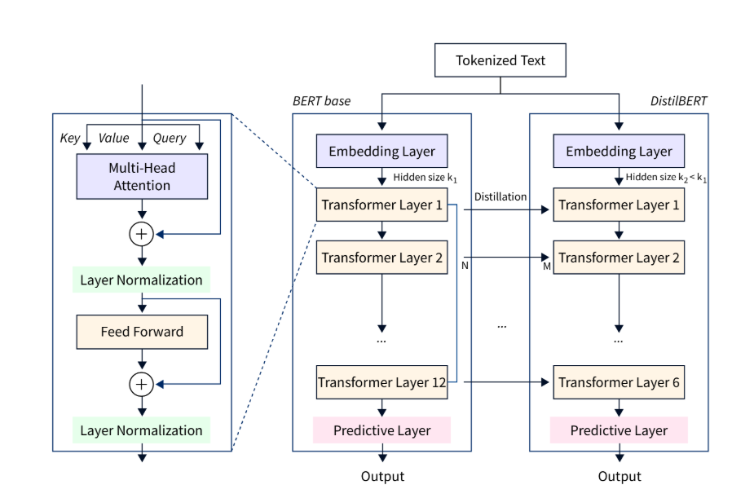
Design and Implementation of an Emotion-Aware Support Chatbot
Data Preprocessing
We began with a dataset containing user messages, emotion labels (angry, frustrated, happy, excited, sad, neutral), and two sets of pre-written replies (neutral and empathetic). After cleaning the data, encoding the emotion labels, and splitting the dataset into an 85/15 training–testing ratio, we obtained a balanced set of samples.
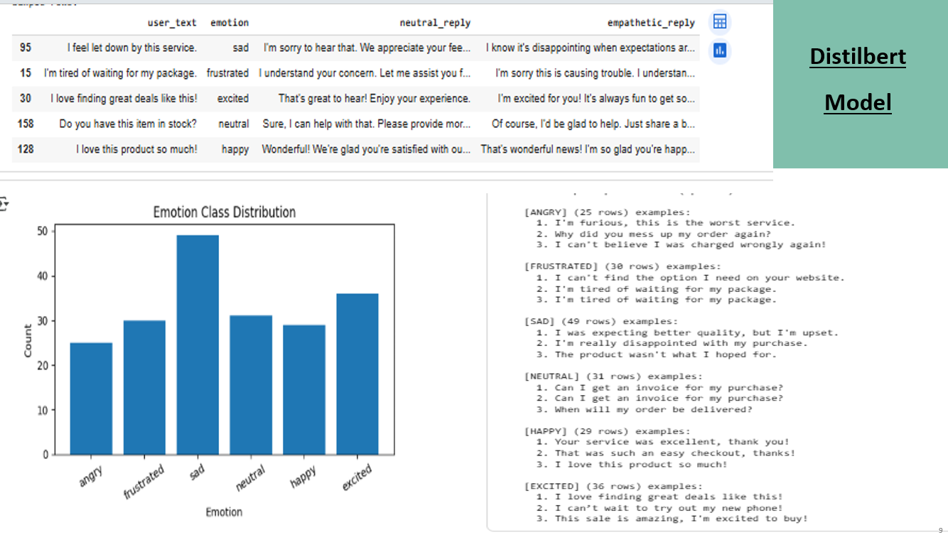
Baseline Model (DistilBERT)
As an initial approach, we fine-tuned DistilBERT as a text classification model for emotion detection. The model was trained for three epochs with a batch size of 16 and a learning rate of 3e-5. The overall accuracy on the test set reached 90%. However, during practical chatbot testing, we observed that despite the high classification accuracy, the responses in conversation were often irrelevant or unnatural. For instance, when the user wrote “I have not received my bag”, the chatbot answered “It is none of my business.” This experiment highlighted that DistilBERT alone is not sufficient for building a functional chatbot.
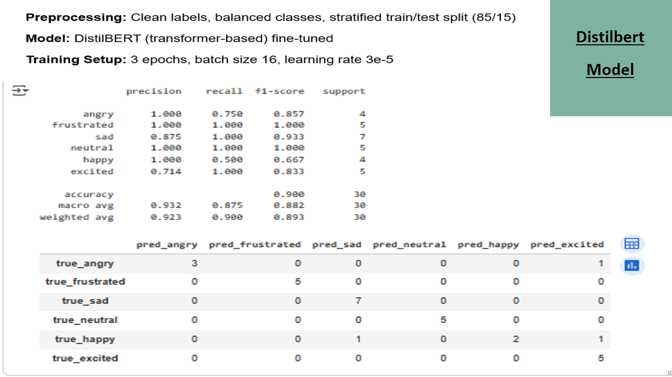
While the model shows acceptable performance on frustrated, sad, neutral, and excited emotions, it clearly struggles with others. For example, angry is misclassified as excited and happy is frequently confused with both sad and excited. This inconsistency highlights a major weakness of relying solely on DistilBERT: although it captures general semantic patterns, it often fails to differentiate between emotions with overlapping expressions. The confusion suggests that DistilBERT alone lacks the robustness needed for a reliable emotion-aware chatbot, and a hybrid approach (e.g., combining with TF-IDF retrieval or additional contextual signals) is necessary to improve precision and reduce misclassification. (The results are based on the test)
Hybrid Architecture (DistilBERT + TF-IDF)
To address this limitation, we designed a hybrid architecture:
- Emotion Detection: The user message is first processed by DistilBERT to identify the underlying emotion.
- Response Retrieval: The user text is then converted into a TF-IDF vector and compared with a bank of pre-written replies. Using cosine similarity, the closest response is retrieved.
- Decision Policy: If the message belongs to the neutral or empathetic categories, the appropriate response is returned. If the message indicates anger or frustration, the conversation is escalated to a human agent.
This design allowed us to leverage the semantic accuracy of DistilBERT while ensuring the responses were contextually relevant and natural, since TF-IDF selected from real pre-written replies.
Scientific Justification
The choice of this hybrid approach is supported by prior research:
- Aprilio et al. (2025) demonstrated that combining TF-IDF vectors with BERT embeddings improves retrieval accuracy compared to using either method alone. TF-IDF captures document-level statistical features, while BERT embeddings model deep linguistic semantics.
- Ibrahim et al. (2025) validated TF-IDF as a fast and effective method for FAQ-style chatbots, although its limitations in semantic understanding are clear.
Therefore, by integrating DistilBERT + TF-IDF, we not only compared the performance against two baselines (TF-IDF only and DistilBERT only) but also developed a system that is fast and simple enough for educational settings while demonstrating the added value of modern NLP models.

First Results:
Our hybrid chatbot system (DistilBERT + TF-IDF retrieval + decision policy) demonstrated promising results in handling business-related and customer support queries. For example, when the user typed “I have not received my bag”, the chatbot responded with relevant support-style replies such as:
- “Of course, I’d be glad to help. Just share a bit more information.” Empathetic Reply
- “Sure, I can help with that. Please provide more details.” Neutral Reply
These responses illustrate that the model performs reasonably well within the domain of structured customer service interactions, where the training data is representative.
However, when the chatbot encountered general or out-of-domain inputs, its performance declined noticeably. In such cases, the system often produced irrelevant or low-confidence responses. This indicates two important lessons:
- Data Coverage: The dataset requires expansion with a wider variety of user queries, including less structured, casual, and adversarial inputs.
- Model Generalization: While the hybrid architecture improved response quality, the model’s effectiveness still depends strongly on the richness and diversity of the training data.
In conclusion, the experiment showed that our system can deliver meaningful replies in its intended customer support domain, but to achieve robustness against open-domain or unexpected queries, we need to both increase dataset variety and potentially explore more advanced generative models in future iterations.
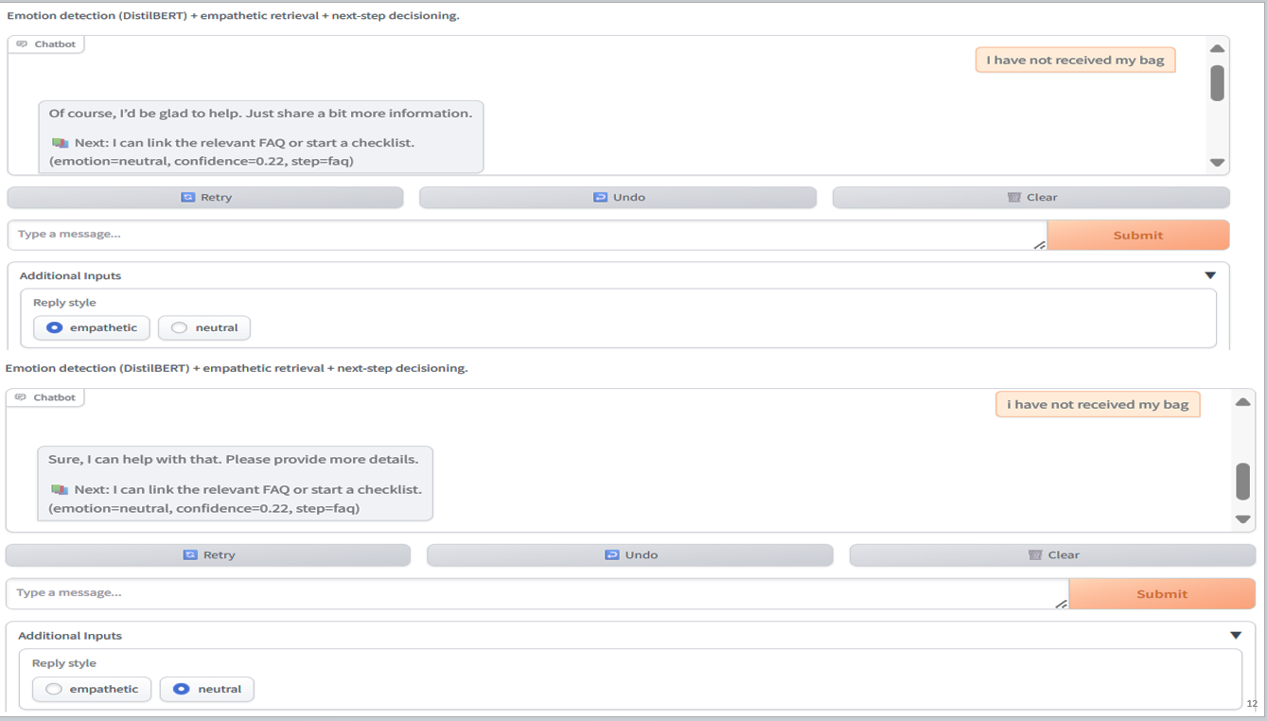
Second part of project:
Dataset Expansion and Enrichment
In the second stage of the project, we expanded our dataset from 200 sentences to 638 sentences. This step was necessary because the initial dataset was too small to capture the variety of real-world customer interactions, which limited the model’s ability to generalize.
To make the dataset more realistic and representative of customer service conversations, we enriched it with additional contextual details, including:
- Ticket numbers (e.g., Order: TC177449)
- Phone numbers (e.g., (416-929-5511))
- Delivery tracking details and addresses
By introducing these structured elements, we exposed the model to more diverse language patterns and real-world formats, which improved both emotion classification and response retrieval.
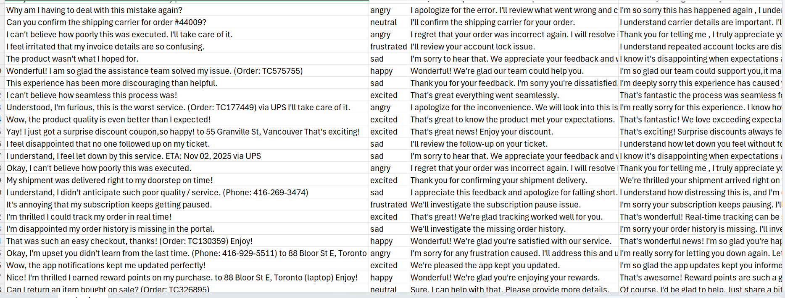
After expansion, the dataset achieved a balanced distribution across six emotions:
- Angry: 113
- Frustrated: 87
- Sad: 111
- Neutral: 105
- Happy: 111
- Excited: 110
This balance is illustrated in the class distribution chart, confirming that no single emotion dominated the dataset. Ensuring balanced classes was critical to prevent bias and to maintain consistent performance across all categories.
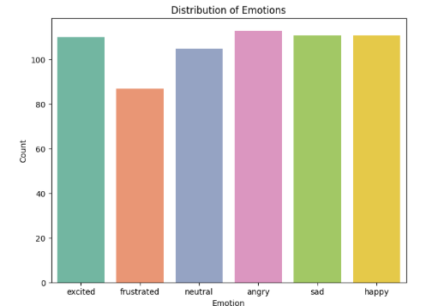
Hyperparameter Optimization with Optuna
To further enhance model performance, we applied hyperparameter tuning using the Optuna library. Instead of selecting values manually, Optuna explored a defined search space and automatically tested multiple configurations, pruning weaker trials early. The search space included: learning rate (5e-6 to 4e-5), weight decay (0.0–0.05), number of epochs (2–4), warmup ratio (0.0–0.1), and learning rate scheduler type (linear or cosine). Model performance in each trial was evaluated using the macro F1-score on the validation set.
The optimization process identified the best configuration with a learning rate of approximately 3.5e-5, weight decay of 0.006, 3 epochs, a warmup ratio of 0.06, and a cosine scheduler. This setup achieved the highest validation accuracy (≈87%) and a macro F1-score of 0.8671, which was the best result across all trials. These results confirm that systematic hyperparameter tuning not only improved accuracy but also provided a more balanced performance across all six emotion classes compared to the default parameters.
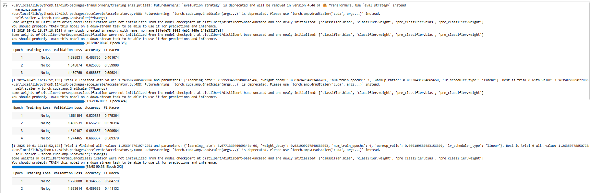
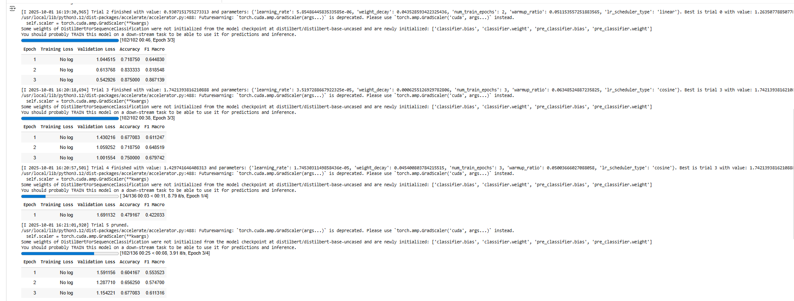

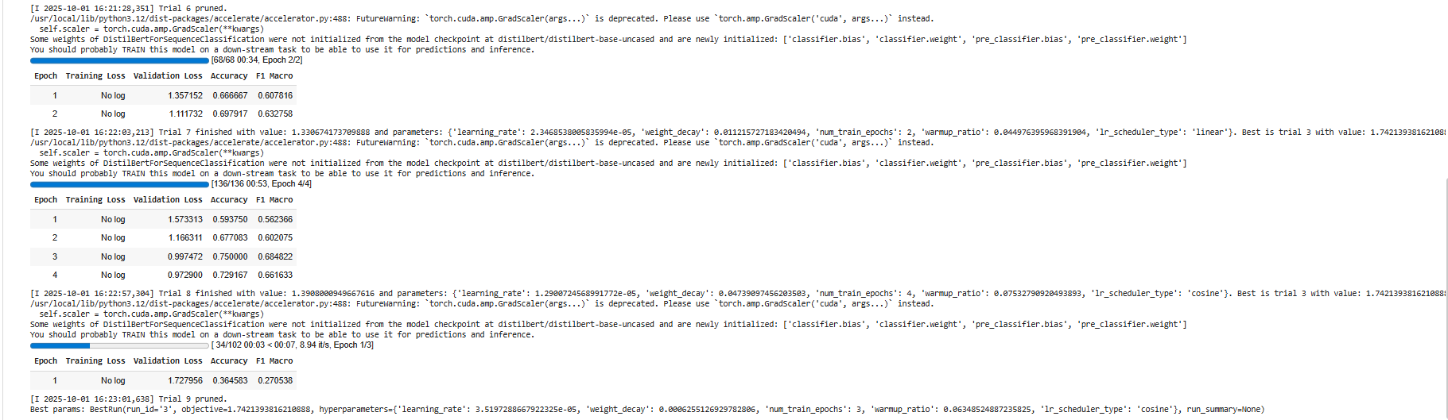
Training Curves (Best Tuned Run)
The figure below illustrates the performance of the model using the best hyperparameter configuration selected by Optuna.
Both training loss and evaluation loss decreased steadily across training steps, with evaluation loss dropping from around 1.15 to below 0.6. This consistent downward trend indicates that the model was learning effectively while avoiding severe overfitting.
At the same time, the evaluation metrics show clear improvement. Validation accuracy increased from about 72% in the first epoch to 87.5% by the final epoch, while the macro F1-score rose from ~0.65 to 0.867. The close alignment between accuracy and F1 demonstrates that the model performed well across all six emotion classes, rather than favoring one category over others.
Overall, these results confirm that the tuned model achieved strong generalization, balancing accuracy and fairness across emotion categories.
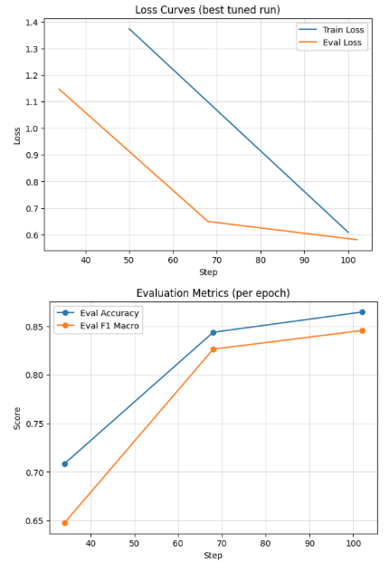
Results from different tests:
First:
Chatbot Testing with User Queries
To evaluate the practical performance of our emotion-aware chatbot, we tested it on several sample user queries. Each test followed three steps:
- Emotion Detection (DistilBERT):
The model predicted the underlying emotion of the user’s message with a probability score.
- Reply Style Selection:
Based on the detected emotion, the system automatically chose either an empathetic or neutral reply style.
  - Negative emotions (angry, sad, frustrated) → empathetic replies.
  - Neutral/positive emotions → neutral replies.
- Response Retrieval (TF-IDF + Similarity Matching):
The chatbot searched the dataset for the closest pre-written reply using cosine similarity, ensuring contextual relevance.
Examples of Test Cases:
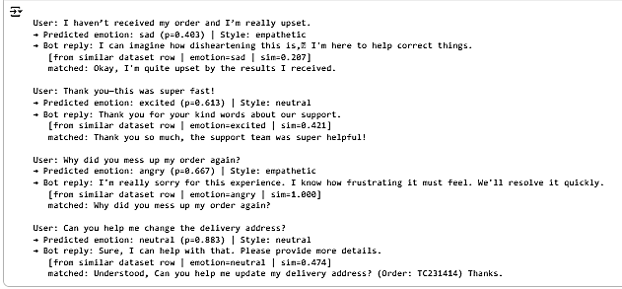
These results demonstrate that the chatbot successfully adapts its tone based on the detected emotion. Negative or frustrated messages received empathetic responses, while neutral or positive ones received straightforward replies. This ensures that the chatbot maintains both accuracy in emotion detection and appropriate response style during real-world interactions.
Second:
We tested the chatbot using sentences from our dataset, and the results were acceptable. This indicates that the model performs well when handling examples drawn directly from the training data.
Empathetic reply
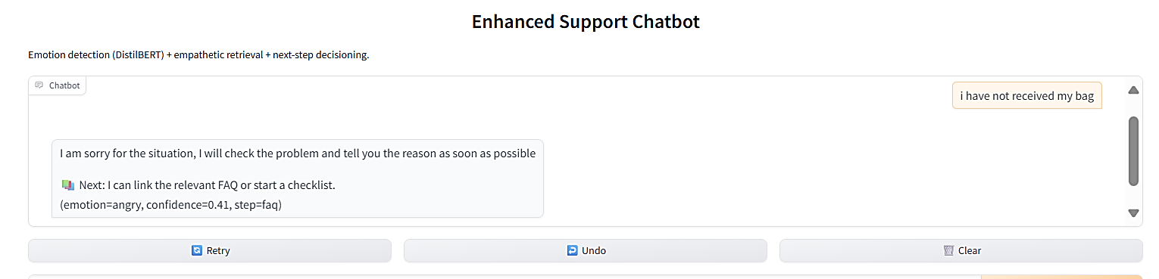
Neutral reply
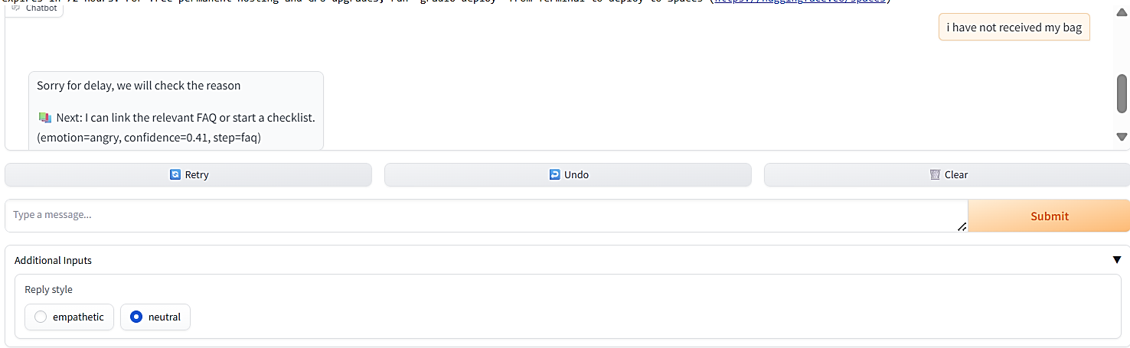
Empathetic reply
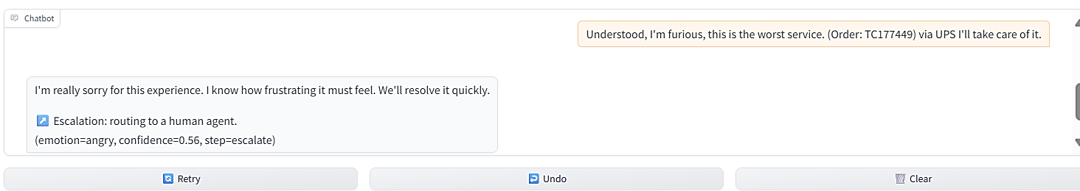
Neutral reply
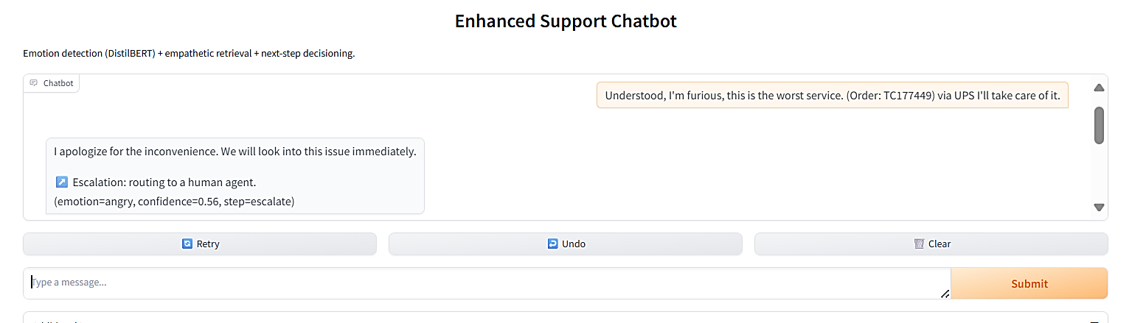
Third:
Original dataset sentence: “My shipment was delivered right to my doorstep on time.”
This is the sentence from main dataset, to evaluate the model’s robustness, we created and tested equivalent variations of this sentence. The chatbot produced acceptable results, showing that it could generalize beyond the exact training sentence and still respond appropriately to semantically similar inputs.
Empathetic Reply:
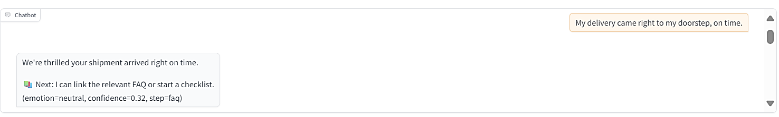
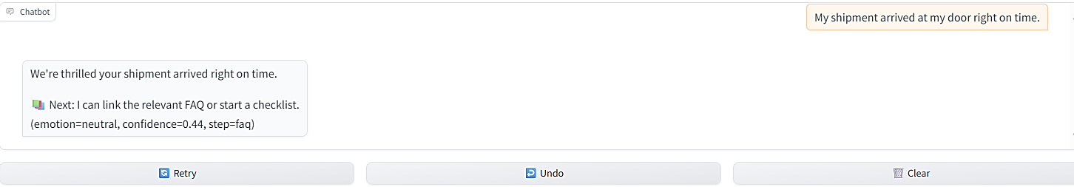
Neutral Reply:
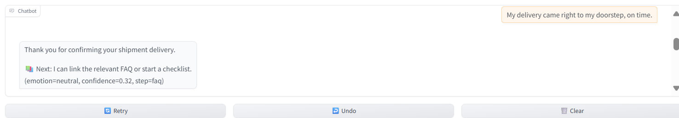
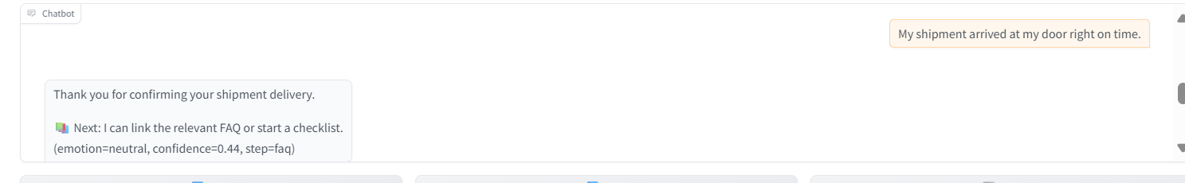
Fourth:
We used numbers and more information about the packages:

Empathetic reply:
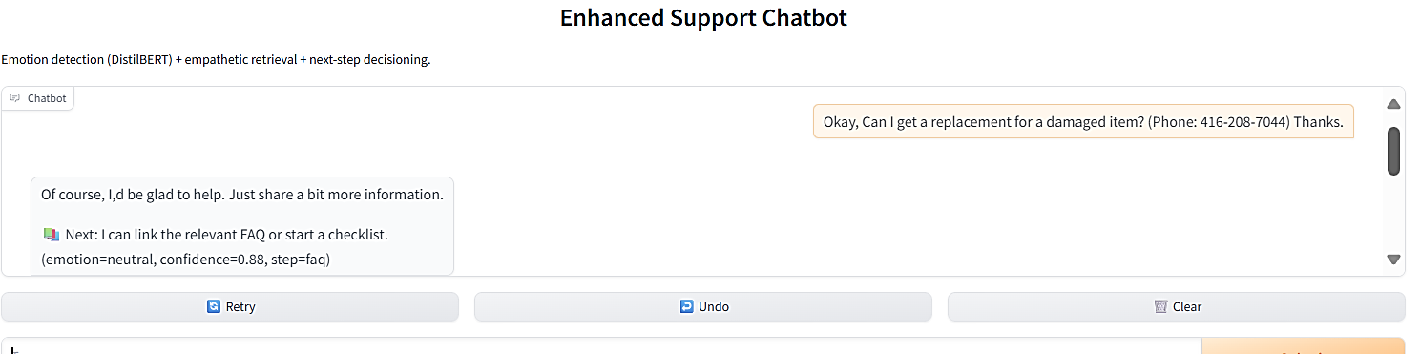
Neutral reply:
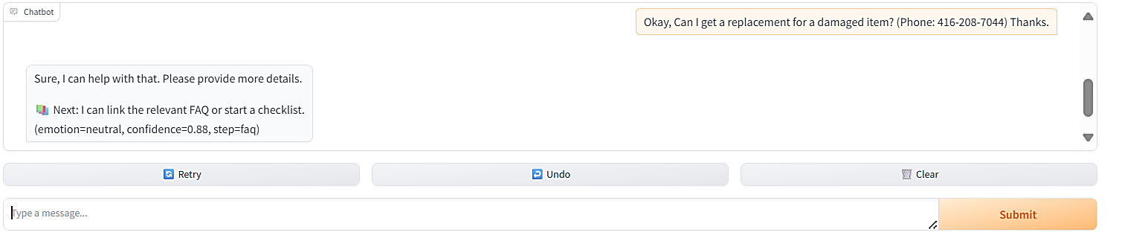
Empathetic reply:
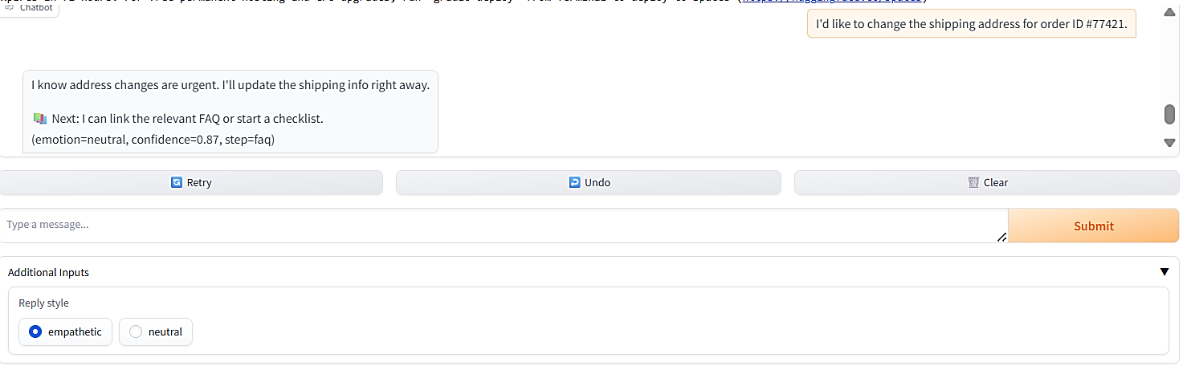
Neutral reply:
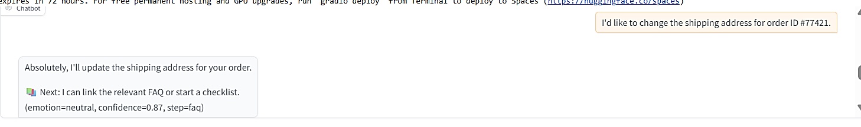
Fifth:
Testing on Unseen Data
In the final stage, we evaluated the chatbot with unseen sentences (examples that were not part of the training dataset). The goal was to check how well the model generalizes beyond the data it was trained on.
The results showed mixed performance:
- In some cases, the chatbot’s reply was relevant, but the emotion prediction was incorrect.
- In other cases, the emotion was predicted correctly, but the generated response was not contextually appropriate.
This indicates that while the model has learned to capture emotional cues and generate responses, its performance decreases when it faces unfamiliar sentence structures or expressions. It highlights the need for larger and more diverse training data, as well as potential fine-tuning with unseen examples, to improve robustness in real-world conversations.
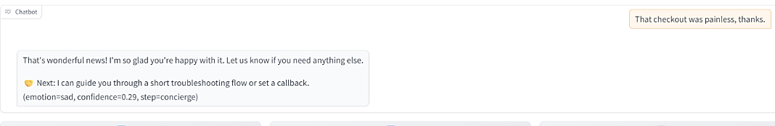
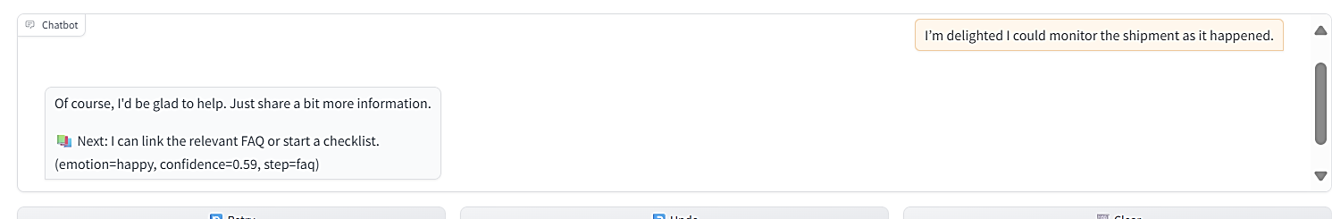
However, the model also was good in some unseen sentences:
Neutral reply:
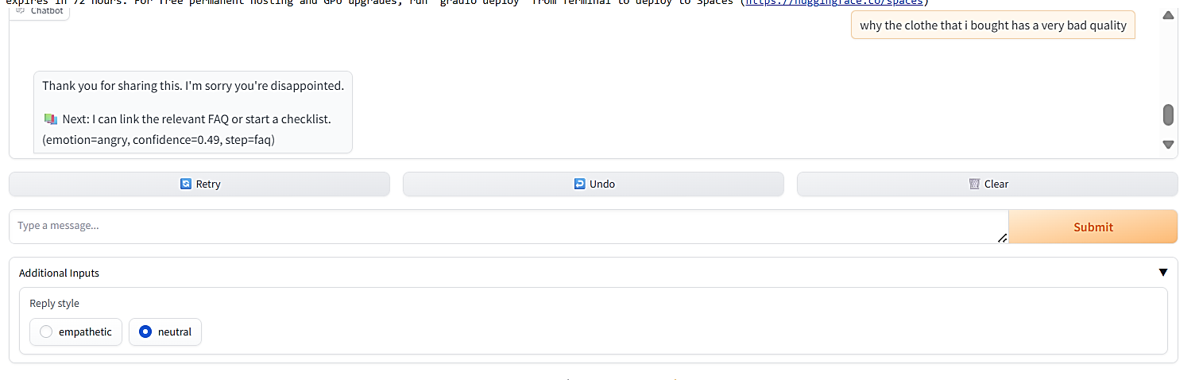
Empathetic reply:
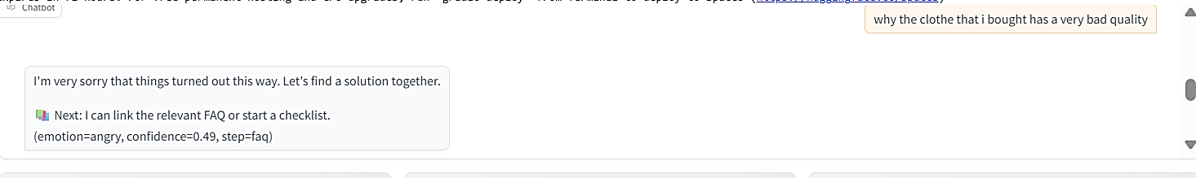
Overall, we concluded that the DistilBERT model needs to be combined with other advanced methods or models to achieve better performance. Furthermore, the dataset should be expanded and improved through several stages of refinement so that a chatbot can be developed with minimal errors and more reliable interactions.

References:
1) Bilquise, G., Ibrahim, S., & Shaalan, K. (2022). Emotionally intelligent chatbots: A systematic literature review. Human Behavior and Emerging Technologies.
Emotionally Intelligent Chatbots: A Systematic Literature Review - Bilquise - 2022 - Human Behavior and Emerging Technologies - Wiley Online Library
2) Elyoseph, Z., Hadar-Shoval, D., Asraf, K., & Lvovsky, M. (2023). ChatGPT outperforms humans in emotional awareness evaluations. Frontiers in Psychology, 14, 1199058.
ChatGPT outperforms humans in emotional awareness evaluations - PubMed
3) Seitz, L., et al. (2024). Artificial empathy in healthcare chatbots: Does it feel authentic? Science Direct.
Artificial empathy in healthcare chatbots: Does it feel authentic? - ScienceDirect
4) Liu, T., Giorgi, S., Aich, A., Lahnala, A., Curtis, B., Ungar, L., & Sedoc, J. (2024). The illusion of empathy: How AI chatbots shape conversation perception. arXiv.
The Illusion of Empathy: How AI Chatbots Shape Conversation Perception | Proceedings of the AAAI Conference on Artificial Intelligence
5) Taiwo, O., & Al-Bander, B. (2025). Emotion-aware psychological first aid: Integrating BERT-based emotional distress detection with Psychological First Aid-Generative Pre-Trained Transformer chatbot for mental health support. Cognitive Computation and Systems, 7(1).
Emotion‐aware psychological first aid: Integrating BERT‐based emotional distress detection with Psychological First Aid‐Generative Pre‐Trained Transformer chatbot for mental health support - Taiwo - 2025 - Cognitive Computation and Systems - Wiley Online Library
6) Benke, I., Gnewuch, U., & Maedche, A. (2022). Understanding the impact of control levels over emotion-aware chatbots. Computers in Human Behavior, 129, 107122.
Understanding the impact of control levels over emotion-aware chatbots - ScienceDirect
7) Jairath, A. (n.d.). Empathetic Dialogues (Facebook AI) [Dataset]. Kaggle.
https://www.kaggle.com/datasets/atharvjairath/empathetic-dialogues-facebook-ai
8) Oracle. (n.d.). Train your model for natural language understanding. Oracle Cloud Infrastructure Documentation.
https://docs.oracle.com/en-us/iaas/digital-assistant/doc/train-your-model-for-natural-language-understanding.html
9) Microsoft. (n.d.). Best practices for conversational language understanding. Azure AI Services Documentation.
https://learn.microsoft.com/en-us/azure/ai-services/language-service/conversational-language-understanding/concepts/best-practices
10) Aprilio, P., Felix, M., Nugraha, P. S., & Fahmi, H. (2025). Hybrid feature combination of TF-IDF and BERT for enhanced information retrieval accuracy. JISA (Jurnal Informatika dan Sains), 8(1), 8–15.
(PDF) Hybrid Feature Combination of TF-IDF and BERT for Enhanced Information Retrieval Accuracy
11) Ibrahim, M. S., Sallibi, A. D., Hadi, A. A., & Nafae, A. A. (2025). A chatbot for frequently asked questions using TF-IDF and query expansion techniques. Passer Journal of Basic and Applied Sciences, 7(1), 506–512.
(PDF) A Chatbot for Frequently Asked Questions using TF-IDF and Query Expansion Techniques

